**EXNO**: **5**

**MOVIE-2**

**AIM**

To prepare a movie with built-in functions of graphics library available in C.

**ALGORITHM**

* Three scenery from nature is created.
* Morning Scenery
* Creation of objects (Sun, Clouds, Tree, Mountain).
* Sun is drawn using fillellipse (xcentre, ycentre, xradius, yradius).
* The branch of the tree is drawn using line (xstart, ystart, xend, yend).
* The leaf of the tree is drawn using fillellipse(xcentre, ycentre, xradius, yradius).
* Mountain is drawn using fillpoly(total number of vertex points, vertex point array).
* Clouds is drawn using ellipse((xcentre, ycentre, startangle, endangle, xradius, yradius).
* The color for the object is filled using setfillstyle(SOLID_FILL, color for the object).
* Rainy Scenery
* Creation of objects (Rain Drops, Clouds, Tree, Mountain).
* Rain Drops is drawn using pieslice (xstart, ystart, startangle, endangle, radius).
* The branch of the tree is drawn using line (xstart, ystart, xend, yend).
* The leaf of the tree is drawn using fillellipse(xcentre, ycentre, xradius, yradius).
* Mountain is drawn using fillpoly(total number of vertex points, vertex point array).
* Clouds is drawn using ellipse((xcentre, ycentre, startangle, endangle, xradius, yradius).
* The color for the object is filled using setfillstyle(SOLID_FILL, color for the object).
* Night Scenery
* Creation of objects (Stars, Moon, Tree, Mountain).
* Stars are drawn using line (xstart, ystart, xend, yend).
* Moon is drawn using fillellipse (xcentre, ycentre, xradius, yradius).
* The branch of the tree is drawn using line (xstart, ystart, xend, yend).
* The leaf of the tree is drawn using fillellipse(xcentre, ycentre, xradius, yradius).
* Mountain is drawn using fillpoly(total number of vertex points, vertex point array).
* The color for the object is filled using setfillstyle(SOLID_FILL, color for the object).
* These images are saved in memory using malloc() and as bitmap image using getimage().
* These images are retrieved using putimage (x_point, y_point, COPY_PUT).
* The scenes are displayed in sequence with delay (time in miiliseconds).

**CODE**

#include<graphics.h>

#include<stdlib.h>

void commonobjects();

void common();

void rain();

void message(char []);

void *p,*cl,*t,*s;

int poly[8],area;

int x1=0,y1=50;

void main()

{

int gd=DETECT,gm,i;

//Initialization Of Graphics Driver And Graphics mode

initgraph(&gd,&gm, "C:\\Turboc3\\BGI");

//Clouds

setlinestyle(0,0,3);

ellipse(200,50,60,240,10,15);

ellipse(225,40,345,165,20,15);

ellipse(262,47,340,160,20,15);

ellipse(268,66,230,50,20,15);

ellipse(226,71,163,340,31,15);

ellipse(300,41,20,182,21,19);

ellipse(325,50,290,100,21,15);

ellipse(299,70,228,20,33,15);

area=imagesize(180,20,350,100);

cl=malloc(area);

getimage(180,20,350,100,cl);

//Rain Drops

setlinestyle(0,0,3);

setfillstyle(SOLID_FILL,11);

setcolor(11);

pieslice(220,120,219,250,10);

area=imagesize(210,119,221,129);

p=malloc(area);

getimage(210,119,221,129,p);

//Tree

setfillstyle(SOLID_FILL,BROWN);

setcolor(BROWN);

line(30,200,30,310);

line(30,280,59,230);

line(30,280,10,230);

setcolor(GREEN);

setfillstyle(SOLID_FILL,GREEN);

fillellipse(30,210,10,15);

fillellipse(59,230,10,10);

fillellipse(10,230,9,10);

area=imagesize(0,195,80,310);

t=malloc(area);

getimage(0,195,75,310,t);

//Star

setcolor(WHITE);

line(11,10,16,10);

line(13,8,13,13);

area=imagesize(10,7,17,14);

s=malloc(area);

getimage(10,7,17,14,s);

cleardevice();

//Ground Points

//1st Vertex

poly[0]=0;

poly[1]=300;

//2nd Vertex

poly[2]=getmaxx();

poly[3]=400;

//3rd Vertex

poly[4]=getmaxx();

poly[5]=getmaxy();

//4th Vertex

poly[6]=0;

poly[7]=getmaxy();

while(!kbhit())

{

//Morning Scenery

setbkcolor(LIGHTBLUE);

message("SUNNY DAY");

commonobjects();

//Sun

setcolor(YELLOW);

setfillstyle(SOLID_FILL,YELLOW);

fillellipse(getmaxx()-80,60,45,45);

delay(5000);

cleardevice();

//Rainy Scenery

for(i=0;i<15;i++)

{

setbkcolor(BLACK);

message("RAINY DAY");

commonobjects();

rain();

cleardevice();

}

//Night Scenery

setbkcolor(BLACK);

message("COOL NIGHT");

common();

//Moon

setcolor(WHITE);

setfillstyle(SOLID_FILL,WHITE);

fillellipse(getmaxx()-80,60,30,30);

delay(5000);

cleardevice();

}

getch();

closegraph();

}

void message(char msg[15])

{

setcolor(WHITE);

settextstyle(0,0,3);

outtextxy(10,10,msg);

}

void commonobjects()

{

putimage(50,30,cl,COPY_PUT );

putimage(250,30,cl,COPY_PUT);

putimage(getmaxy()-15,30,cl,COPY_PUT);

setfillstyle(SOLID_FILL,BROWN);

setcolor(BROWN);

fillpoly(4,poly);

putimage(0,192,t,COPY_PUT);

putimage(80,200,t,COPY_PUT);

putimage(160,213,t,COPY_PUT);

putimage(240,225,t,COPY_PUT);

putimage(320,238,t,COPY_PUT);

putimage(400,252,t,COPY_PUT);

putimage(480,265,t,COPY_PUT);

putimage(560,275,t,COPY_PUT);

}

void common()

{

int x=10;

setfillstyle(SOLID_FILL,BROWN);

setcolor(BROWN);

fillpoly(4,poly);

putimage(0,192,t,COPY_PUT);

putimage(80,200,t,COPY_PUT);

putimage(160,213,t,COPY_PUT);

putimage(240,225,t,COPY_PUT);

putimage(320,238,t,COPY_PUT);

putimage(400,252,t,COPY_PUT);

putimage(480,265,t,COPY_PUT);

putimage(560,275,t,COPY_PUT);

for(;x<getmaxx();x+=10)

putimage(random(getmaxx()),random(180),s,COPY_PUT);

}

void rain()

{

if((x1>=0)&&(y1<=280))

{

putimage(x1,y1,p,COPY_PUT);

putimage(x1+50,y1,p,COPY_PUT);

putimage(x1+50,y1+30,p,COPY_PUT);

putimage(x1+100,y1+20,p,COPY_PUT);

putimage(x1+150,y1,p,COPY_PUT);

putimage(x1+250,y1+30,p,COPY_PUT);

putimage(x1+550,y1+20,p,COPY_PUT);

putimage(x1+650,y1,p,COPY_PUT);

putimage(x1+210,y1+19,p,COPY_PUT);

putimage(x1+190,y1+25,p,COPY_PUT);

putimage(x1+240,y1+40,p,COPY_PUT);

putimage(x1+500,y1,p,COPY_PUT);

putimage(x1+500,y1+30,p,COPY_PUT);

putimage(x1+600,y1+20,p,COPY_PUT);

putimage(x1+600,y1+20,p,COPY_PUT);

putimage(x1+300,y1,p,COPY_PUT);

putimage(x1+400,y1,p,COPY_PUT);

putimage(x1+100,y1,p,COPY_PUT);

putimage(x1+200,y1+40,p,COPY_PUT);

putimage(x1+300,y1+50,p,COPY_PUT);

putimage(x1+400,y1+40,p,COPY_PUT);

putimage(x1+350,y1+55,p,COPY_PUT);

putimage(x1+450,y1+45,p,COPY_PUT);

putimage(x1+100,y1+50,p,COPY_PUT);

putimage(x1+200,y1+80,p,COPY_PUT);

putimage(x1+300,y1+70,p,COPY_PUT);

putimage(x1+400,y1+80,p,COPY_PUT);

putimage(x1+100,y1+70,p,COPY_PUT);

putimage(x1+500,y1+40,p,COPY_PUT);

putimage(x1+600,y1+50,p,COPY_PUT);

putimage(x1+500,y1+80,p,COPY_PUT);

putimage(x1+600,y1+70,p,COPY_PUT);

putimage(x1+500,y1+80,p,COPY_PUT);

putimage(x1+600,y1+70,p,COPY_PUT);

putimage(x1,y1,p,COPY_PUT);

y1=y1+20;

delay(210);

}

else

{

x1=0;

y1=50;

}

}

**OUTPUT**

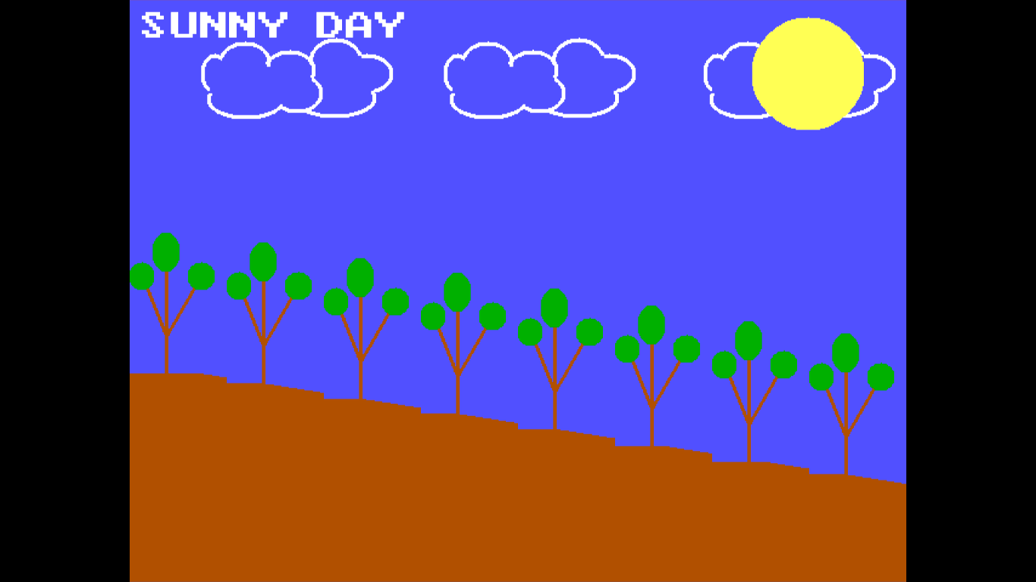

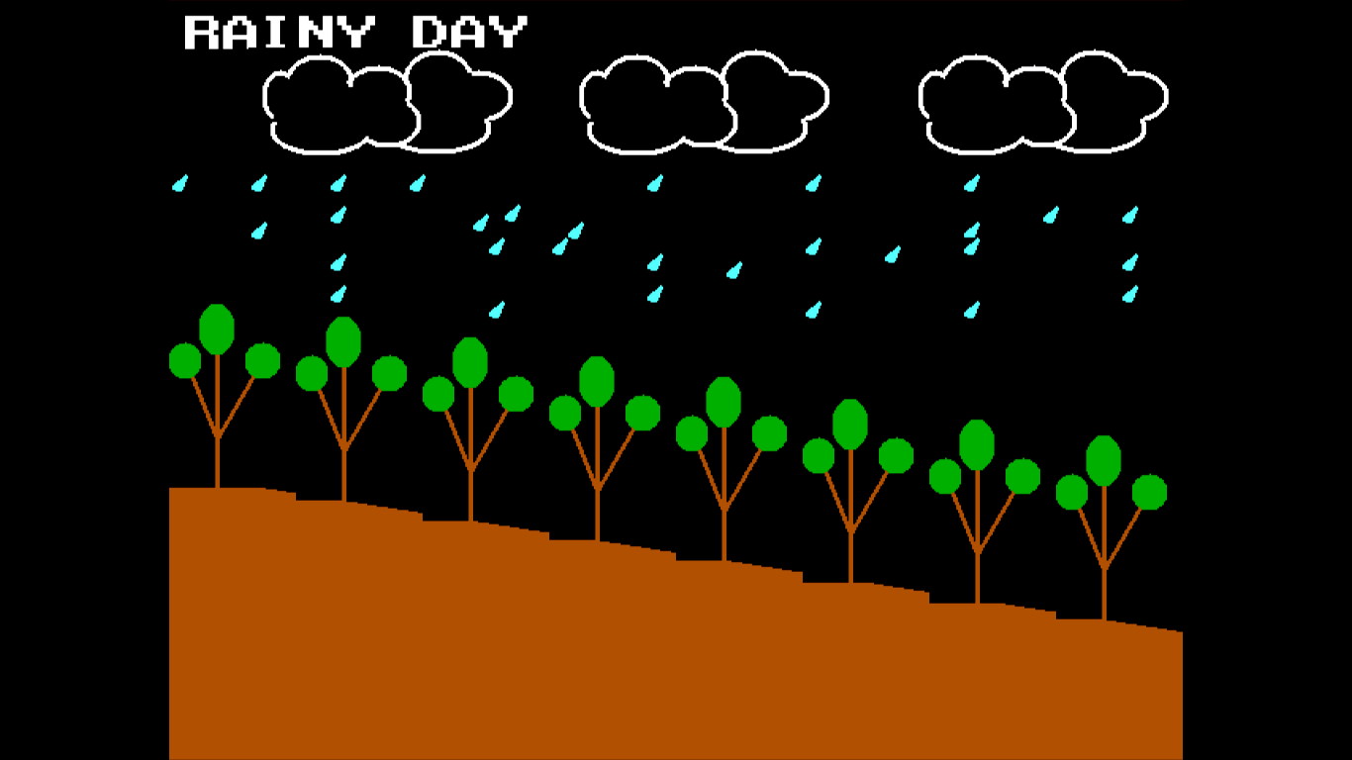

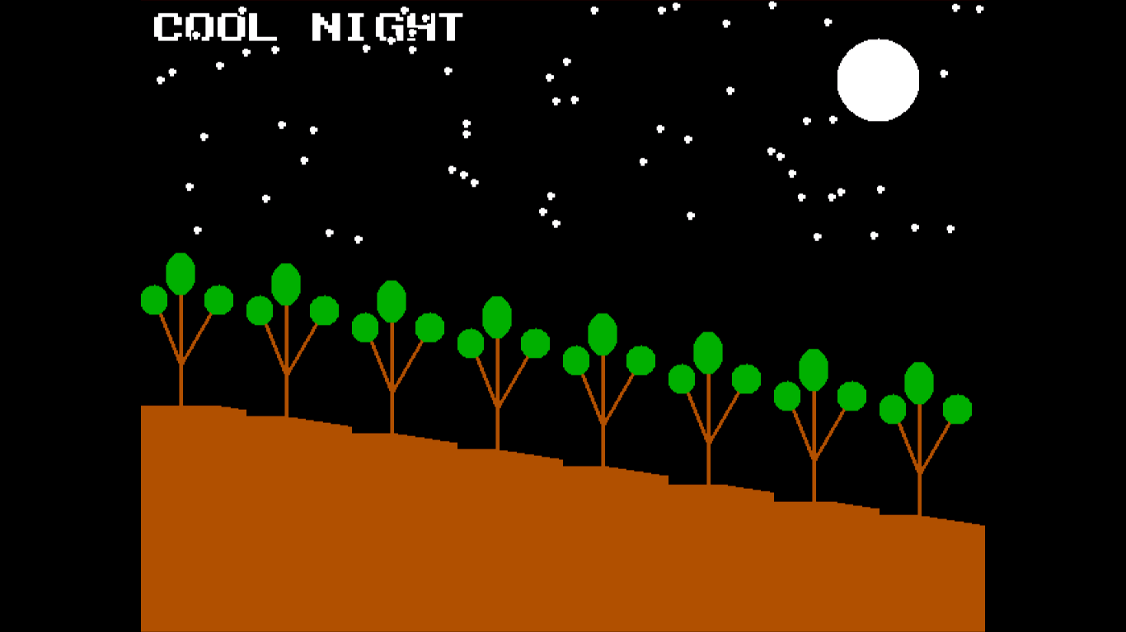

|  |  |  |
| --- | --- | --- |
| **ALGORITHM** | **CODE** | **OUTPUT** |
|  |  |  |

**RESULT**

Thus, Movie is prepared using built-in functions available in C graphics library.